Biscuit
Sausage
Pepper gravy
Fresh fruit
Milk
Juice
Or
Cereal,fruit,milk,juice
Biscuit
Sausage
Pepper gravy
Fresh fruit
Milk
Juice
Or
Cereal,fruit,milk,juice

Thanksgiving Break
Biscuit ,sausage
Pepper gravy,fresh fruit
Milk,juice
Or cereal,milk ,juice,fruit
Veteran’s Day
Cinnamon toast
Fresh fruit
Sausage
Milk
Juice
Or
Cereal,fruit,milk,juice
Breakfast pizza
Bacon & egg,gravy
Fresh fruit
Milk
Juice
Or
Cereal,fruit,milk,juice

Pancakes
Syrup cup
Sausage
Fresh fruit
Milk
Juice
Or
Cereal,fruit,milk,juice

French toast sticks
Syrup cup
Fresh fruit
Milk
Juice
Or
Cereal, fruit,milk,juice

*
Cheesey omlette
Toast
Fresh fruit
Milk
Juice
Or
Cereal,fruit,milk,juice

Breakfast burrito
Fegg,sausge,cheese
Fresh fruit
Milk
Juice
Or
Cereal,fruit,milk,juice

Hash brown
Sausage
Fresh fruit
Milk
Juice
Or
Creal,fruit,milk,juice

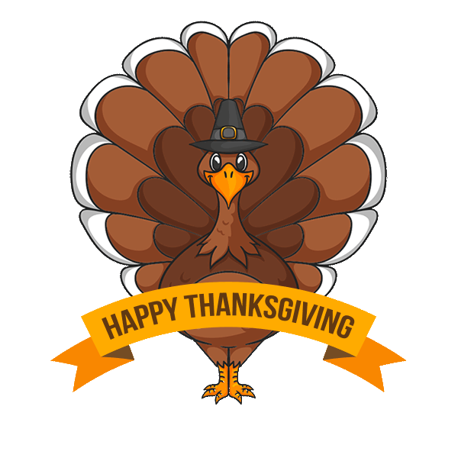
*
Donuts
Sausage
Fresh fruit
Milk
Juice
Or
Cereal,fruit,milk juice
Butter toast
Oatmeal
Fresh fruit
Milk
Juice
Or
Cereal,fruit,milk,juice

Blueberry crunch
Sausage
Fresh fruit
Milk
Juice
Or
Cereal,fruit,milk,juice

Pancake sauage stick
Syrup cup
Fresh fruit
Milk
Juice
Or
Cereal,fruit,milk,juice
Egg n cheese biscuit
Sausage
Patty
Fresh fruit
Milk
Juice
Or
Cereal,fruit,milk,juice

Biscuit
Sausage
Pepper gravy
Fresh fruit
Milk
Juice
Or
Cereal,fruit,milk,juice

*
Grandfield Schools
School News
Breakfast

THIS INSTITUTION IS AN EQUAL OPPORTUNITY PROVIDER

Menu subject to changes as needed.
